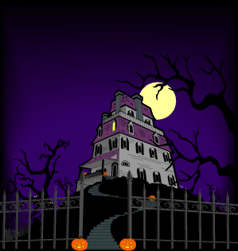

7:00 Open

School Committee – Budget Update

Technology Committee Interviews

Call to Order
7:30 Citizen Comments

7:35 Board of Health Update

8:00 Water Commissioners Update

Approval of Minutes
Appointments
Old Business
New Business

- One Day License Request from the North & South River Watershed
- Set Annual Town Meeting Date
- Set Annual Town Election Date
- Police Station Override Information

Upcoming Meetings
Announcements
Adjournment
Executive Session

